**SIMRAN ADHIKARI**

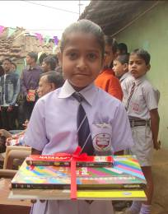

**PERSONAL DETAILS:**

* Class: V
* Gender: Female
* School: Central Public School,

Adityapur

* Board of School: CBSE
* Medium of instruction: English

**DETAILS ABOUT FAMILY:**

* Father’s name: Shyam Adhikari
* Mother’s name: Babita Devi
* No of members in family: Five, one sister, one brother, mother and father
* Profession of father: Machine operator in a local company in Adityapur Industrial Area
* Profession of mother: Housewife

**FINANCIAL OVERVIEW:**

Monthly net income of household: Rs. 3500/-

**Total annual expenditure on education: Rs. 13,350/-**

Breakup of expenses

Tuition fees: Rs 450/- (per month) = Rs. 5400/- (per year)

Admission fees: Rs. 4650/- (per year)

Stationery: Rs. 3300/- (per year)

**Average monthly expenditure on education: Rs. 1100/-**

**ENCLOSURES:**

1) Report card for the final exam of class IV (previous class attended).

Report card – Page 1

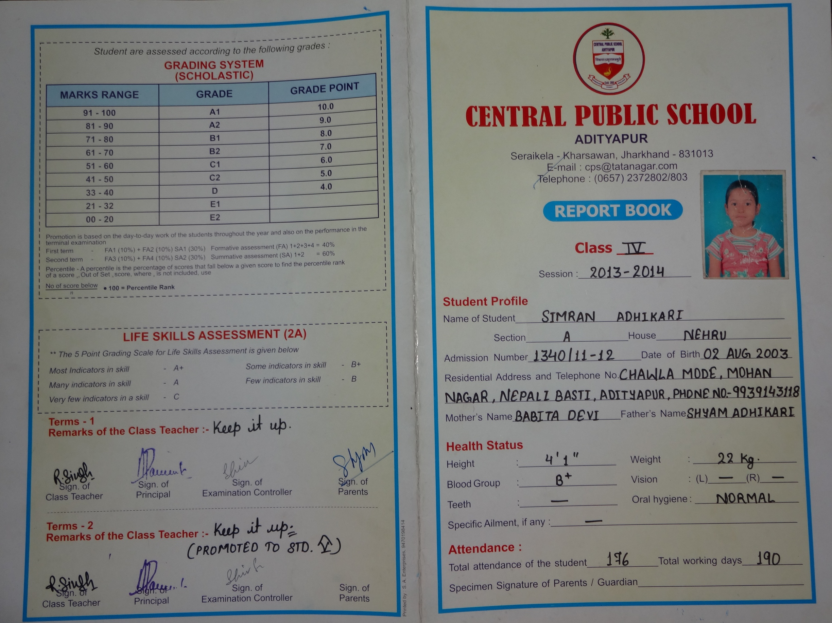

Report Card – Page 2

